1. Write a C program to simulate the following CPU scheduling algorithm to find turnaround time and waiting time.
2. a) FCFS  
    b) SJF
3. #include<stdio.h>
4. int bt[20], wt[20], tat[20], i, p;
5. float wtavg, tatavg;
6. void fcfs(){
7. printf("Enter number of processes: ");
8. scanf("%d", &p);
9. printf("Enter burst time for the following processes:\n");
10. for (int i=0; i<p ; i++){
11. printf( "p%d: ", i);
12. scanf("%d", &bt[i]);
13. }
15. wt[0]= wtavg = 0;
16. tat[0] = bt[0];
17. tatavg =0;
18. for (int i =1; i<p; i++){
19. wt[i]= wt[i-1]+bt[i-1];
20. }
21. for (int i =0; i<p; i++){
22. tat[i]= wt[i]+bt[i];
23. wtavg += wt[i];
24. tatavg += tat[i];
25. }
26. printf("Process\tBurst Time\tWaiting Time\tTurn Around Time\n");
27. for (int i=0; i<p; i++){
28. printf("P%d\t\t%d\t\t%d\t\t%d\n", i, bt[i], wt[i], tat[i]);
30. }
31. printf("\nAverage Turn Around time: %.2f", tatavg/p);
32. printf("\nAverage Waiting time: %.2f", wtavg/p);
33. }
34. void main(){
35. fcfs();
36. }

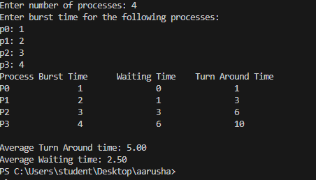

#include <stdio.h>

void main(){

    int n,i,j,temp,bt[20],p[20],wt[20],tat[20];

    printf("Enter Total Number of Processes: ");

    scanf("%d",&n);

    for(i=0;i<n;i++){

        printf("Enter Burst Time for Process %d: ",i+1);

        scanf("%d",&bt[i]);

        p[i]=i+1;

    }

    for(i=0;i<n;i++){

        for (j=i+1;j<n;j++){

            if(bt[i]>bt[j]){

                temp=bt[i];

                bt[i]=bt[j];

                bt[j]=temp;

                temp=p[i];

                p[i]=p[j];

                p[j]=temp;

            }

        }

    }

    float wta=0,tata=bt[0];

    wt[0]=0;

    tat[0]=bt[0];

    for(i=1;i<n;i++){

        wt[i]=wt[i-1]+bt[i-1];

        tat[i]=tat[i-1]+bt[i];

        wta+=wt[i];

        tata+=tat[i];

    }

    wta/=n;

    tata/=n;

    printf("\nProcess\tBurst Time\tWaiting Time\tTurnaround Time\n");

    for (i=0;i<n;i++){

        printf("P%d\t%d\t\t%d\t\t%d\n",p[i],bt[i],wt[i],tat[i]);

    }

    printf("\nAverage Waiting Time = %.2f",wta);

    printf("\nAverage Turnaround Time = %.2f",tata);

}

